**Challenges faced while Integrating Ontap from AWS with CM 2.2**

(MARCH 2021)

**Challenge 1 : (Before creating working environment)**

In order to create working environment with Ontap connector, it is needed to have S3 endpoint service (endpoint type of Gateway) in your VPC

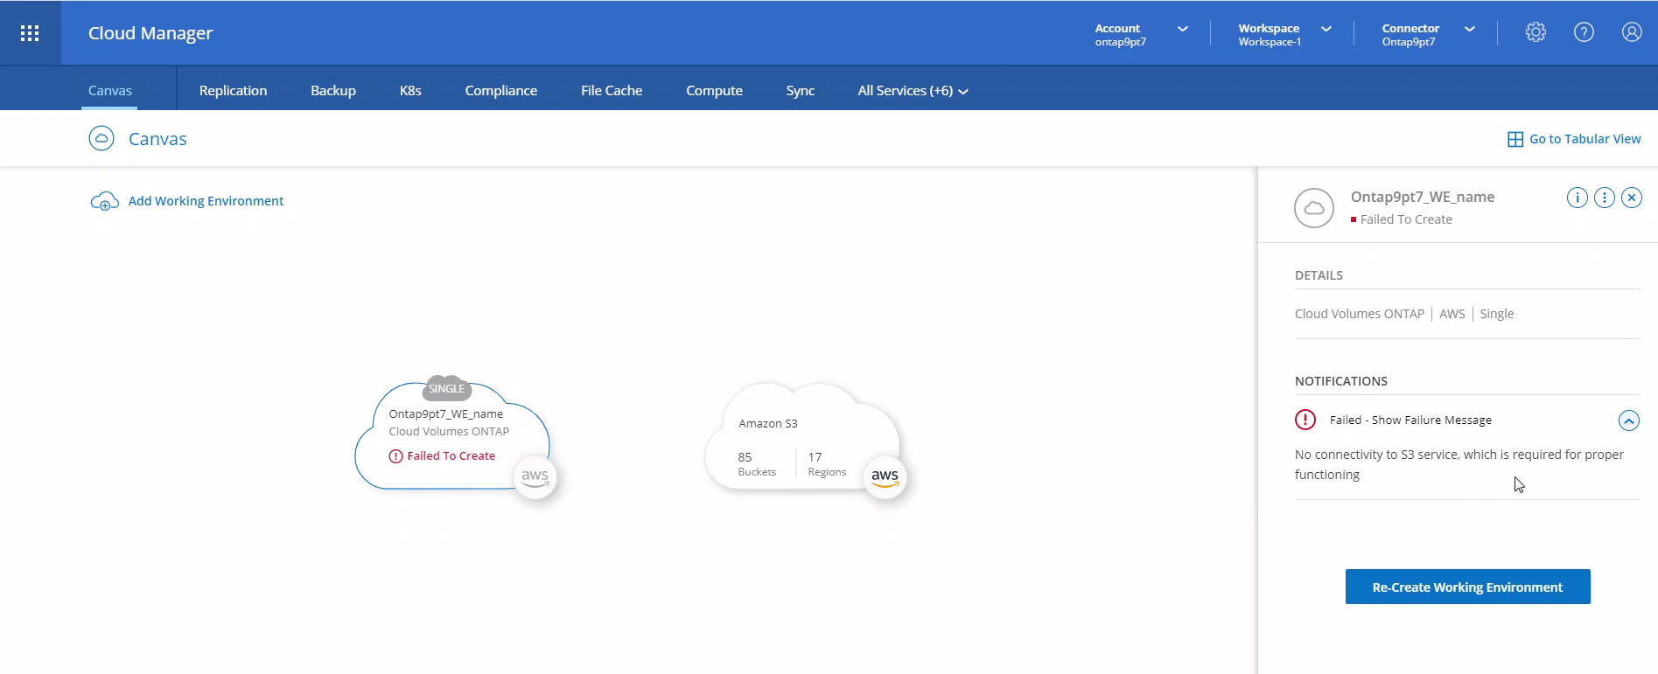

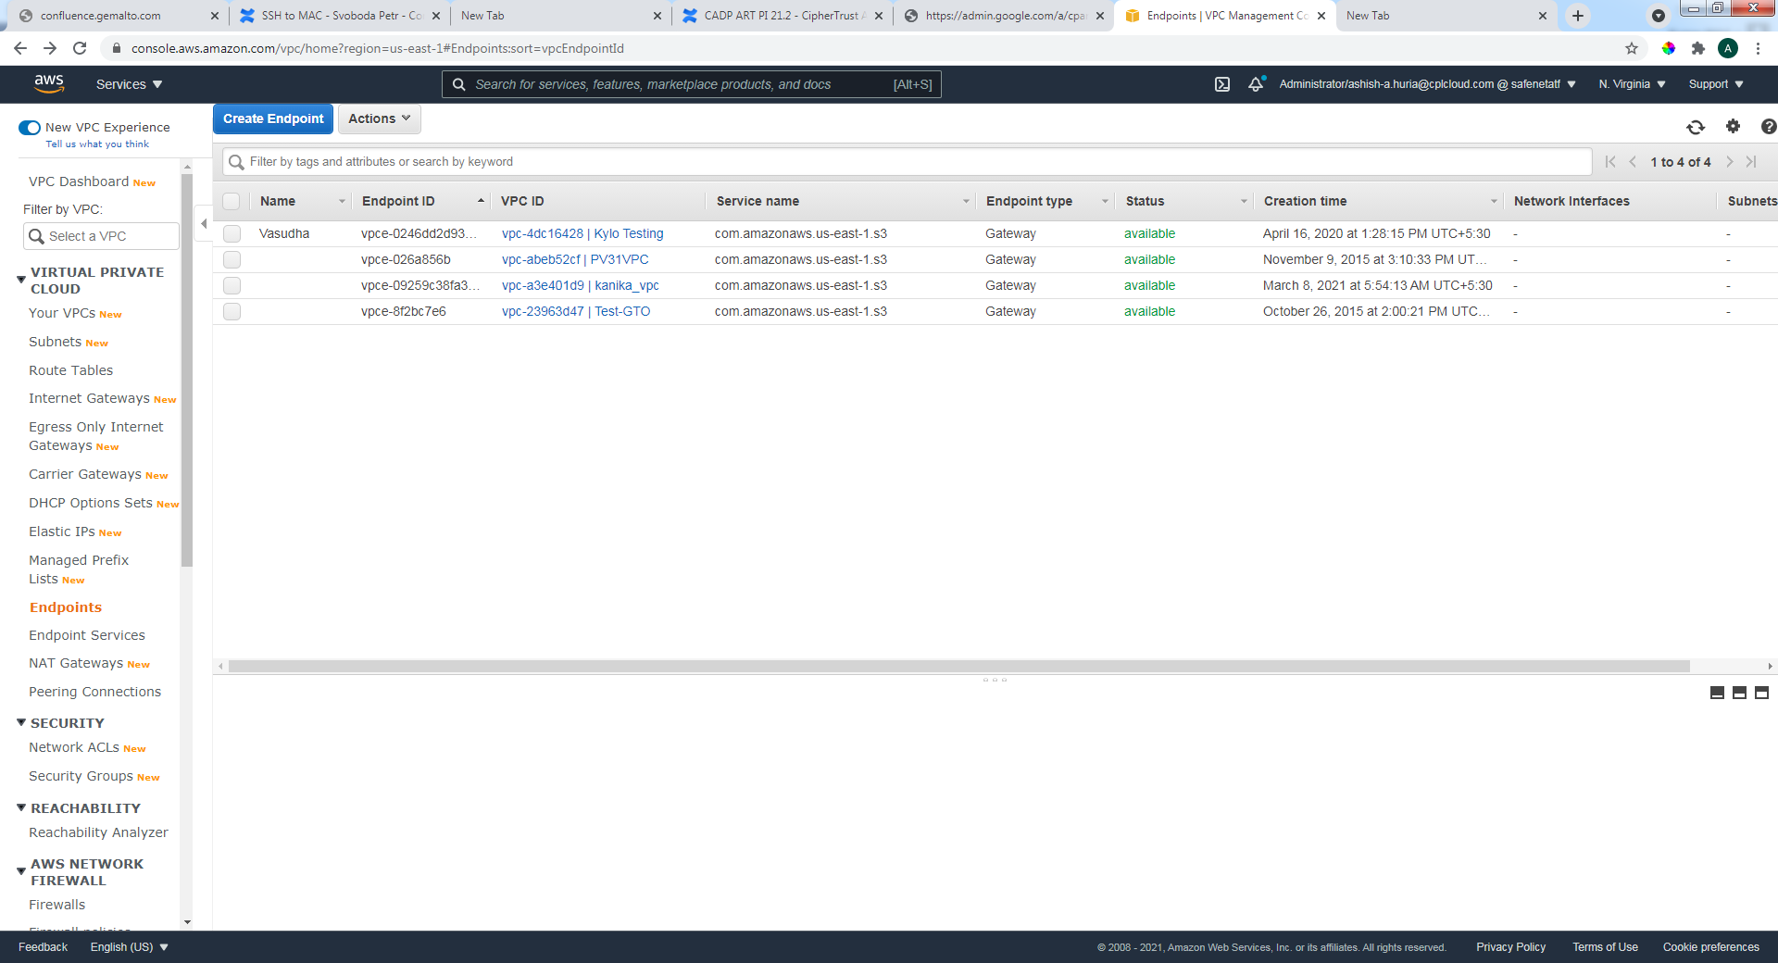Networking & Content Delivery 🡺VPC 🡺 Endpoints

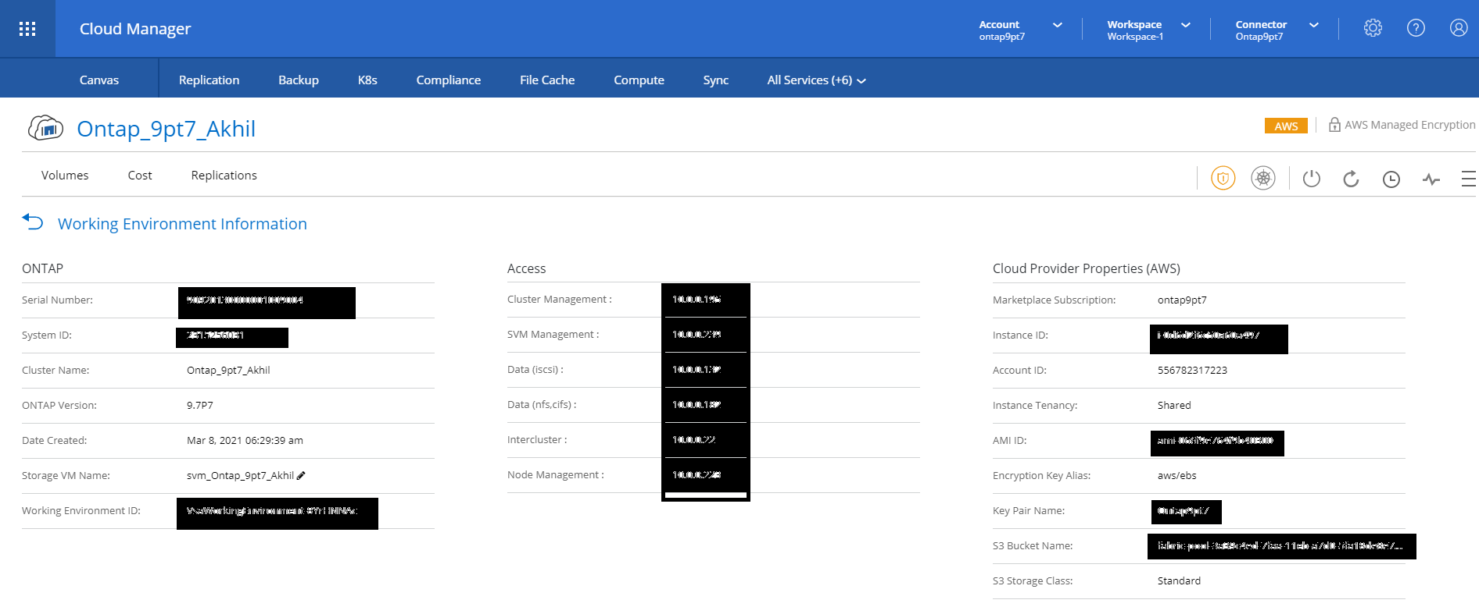

**Challenge 2: (while setting up the interface configuration)**

Enable hard delete flag should be **checked**

Auto Registration flag should be **checked (Tokenized)**

Mode should be **TLS, verify client cert, user name taken from client cert, auth request is optional**

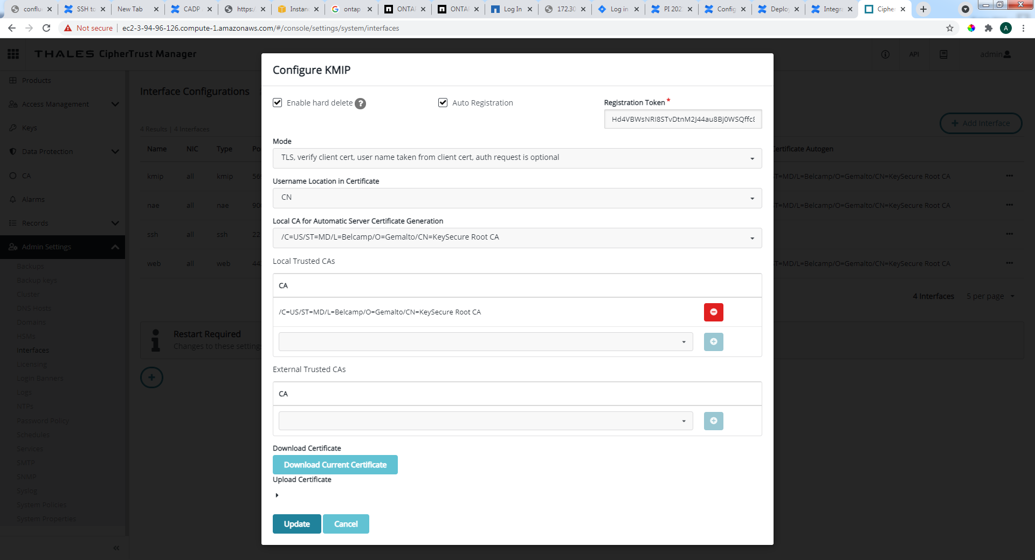

**Note* In AWS Security group which is configured for working environment and CM2.2, TCP port 5696 should be open.**

**Challenge 3: (after running testing script)**  
  
After running the script, you need to login with password as Keyboard Interactivity is needed…  
In that case you may need to create new user of type Admin from Cloud manager DNS url (can be obtained from EC2 Instance) with credential type Password.

Cluster 🡺settings 🡺 User and Roles 🡺 Add User

